

SOFTWARE DESIGN SPECIFICATION
Happy Programming

– Hanoi, Sep 2025 –

I. Record of Changes
Date | A*  M, D | In charge | Change Description
3/10 | A | Lương, Linh | Added Software Architecture, Package Diagram, Database Design
6/1
*A - Added M - Modified D - Deleted

Table of Contents

I. Record of Changes 3
II. Software Design Document 4
1. High Level Design 4
1.1 Software Architecture 4
1.2 Package Diagram 5
1.3 Database Design 8
1.3.1 users 10
1.3.2 user_permissions 11
1.3.3 auth_identities 11
1.3.5 mentor_profiles 12
1.3.7 mentor_applications 13
1.3.8 skill_categories 14
1.3.9 skills 14
1.3.10 mentor_application_skills 14
1.3.11 mentor_skills 15
1.3.12 service_offerings 15
1.3.13 wishlists 16
1.3.14 mentorship_requests 16
1.3.15 mentorship_request_skills 17
1.3.16 availability_rules 18
1.3.17 availability_exceptions 18
1.3.18 slot_holds 19
1.3.19 subscriptions 19
1.3.20 bookings 20
1.3.21 action_items 22
1.3.22 payments 23
1.3.23 payment_events 24
1.3.24 refunds 24
1.3.25 escrow_ledger_entries 25
1.3.26 conversations 26
1.3.27 messages 26
1.3.28 reviews 27
1.3.29 attachments 28
1.3.30 system_configs 28
1.3.31 audit_logs 29
2. State Transition Diagrams 29
2.1 PIN Validation 30
3. Detailed Design 30
3.1 Monthly mentorship booking and SePay Payment 30
3.1.1 Class Diagram 31
3.1.2 Submit Monthly Mentorship Request Sequence Diagram 31
3.1.3 Review Monthly Mentorship Request Sequence Diagram 32
3.1.4 Process Monthly Mentorship Payment via SePay Sequence Diagram 33
3.1.Class diagram : Mentor Registration and Approval 34
3.1.1 .Sequence diagram : Mentor Registration and Approval 35
3.2 Account Status 36
3.2.1 Class diagram 36
3.2.2 Sequence 36
3.3 Staff Permission 37
3.3.1 Class diagram 37
3.2.2 Sequence 38
3.4 Mentor Payout Management 39
3.4.1 Class Diagram 39
3.4.2 Sequence 41

II. Software Design Document

1. High Level Design

1.1 Software Architecture(All Member)
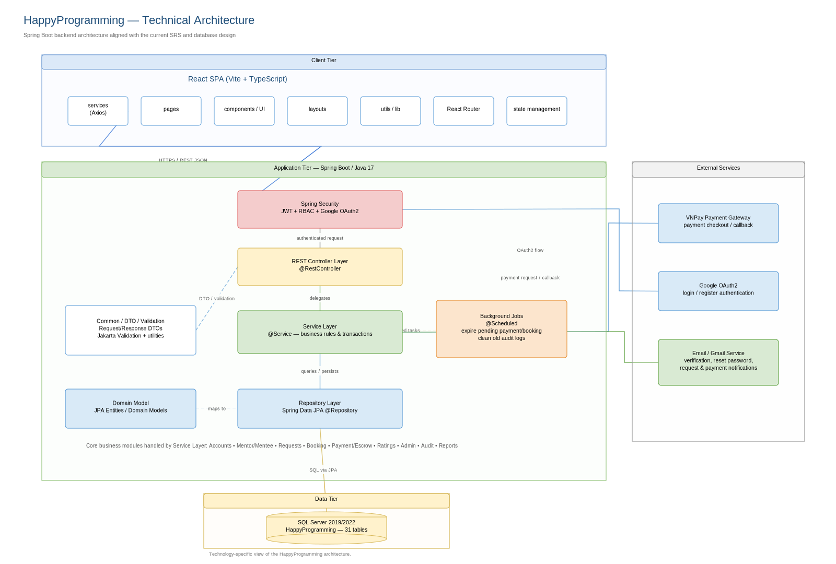

1.2 Package Diagram(All Member)

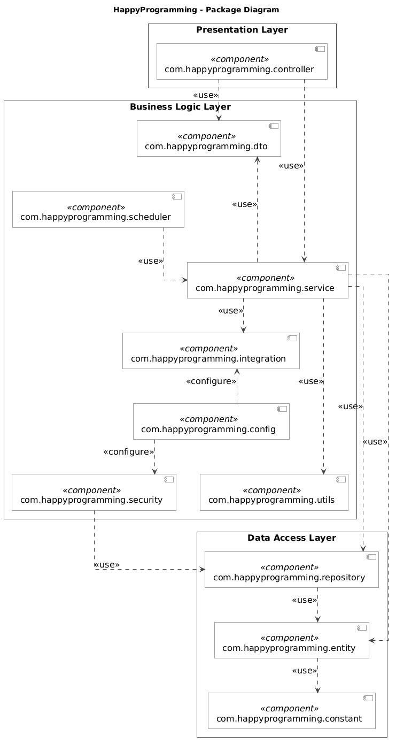

No | Package | Description
01 | com.happyprogramming.config | Contains application configurations, including SQL Server connections, Spring beans, security settings, WebSocket setup, and external service configurations.
02 | com.happyprogramming.constant | Stores shared constants and enumerations, including user roles, Staff permissions, mentorship request statuses, booking statuses, and payment statuses, to avoid hardcoding across the application.
03 | com.happyprogramming.controller | Handles HTTP requests for authentication, mentor discovery, mentorship applications, bookings, payments, reviews, and administration. Validates request data and delegates business processing to the service layer.
04 | com.happyprogramming.dto | Contains Data Transfer Objects for exchanging request and response data between layers. Supports input validation and prevents sensitive entity fields from being exposed to clients.
05 | com.happyprogramming.entity | Contains JPA entities mapped to SQL Server database tables, including users, mentor profiles, mentorship requests, subscriptions, bookings, payments, messages, and reviews. Defines persistent fields and relationships between entities.
06 | com.happyprogramming.repository | Contains Spring Data JPA repository interfaces and custom queries for retrieving, creating, updating, and deleting persistent data. Supports pagination and locking where required.
07 | com.happyprogramming.service | Implements core business logic for mentor approval, mentorship applications, scheduling, subscriptions, payments, escrow accounting, messaging, and reviews. Coordinates transactions and ensures monthly mentorship is activated only after mentor acceptance and verified payment.
08 | com.happyprogramming.security | Handles authentication and authorization using Spring Security, including Google OAuth2 login, password hashing, role-based access control, individual Staff permissions, and resource ownership checks.
09 | com.happyprogramming.integration | Provides adapters for external services, including Sepay and Gmail email delivery. Handles external requests, responses, and integration errors.
10 | com.happyprogramming.scheduler | Contains scheduled tasks for expiring unanswered mentorship requests, pending payments, and temporary slot holds, as well as processing subscription lifecycle changes and permitted log cleanup. Calls service methods to execute business rules.
11 | com.happyprogramming.utils | Provides reusable helper classes for date and time conversion, data formatting, reference generation, and other common operations used throughout the application.

1.3 Database Design

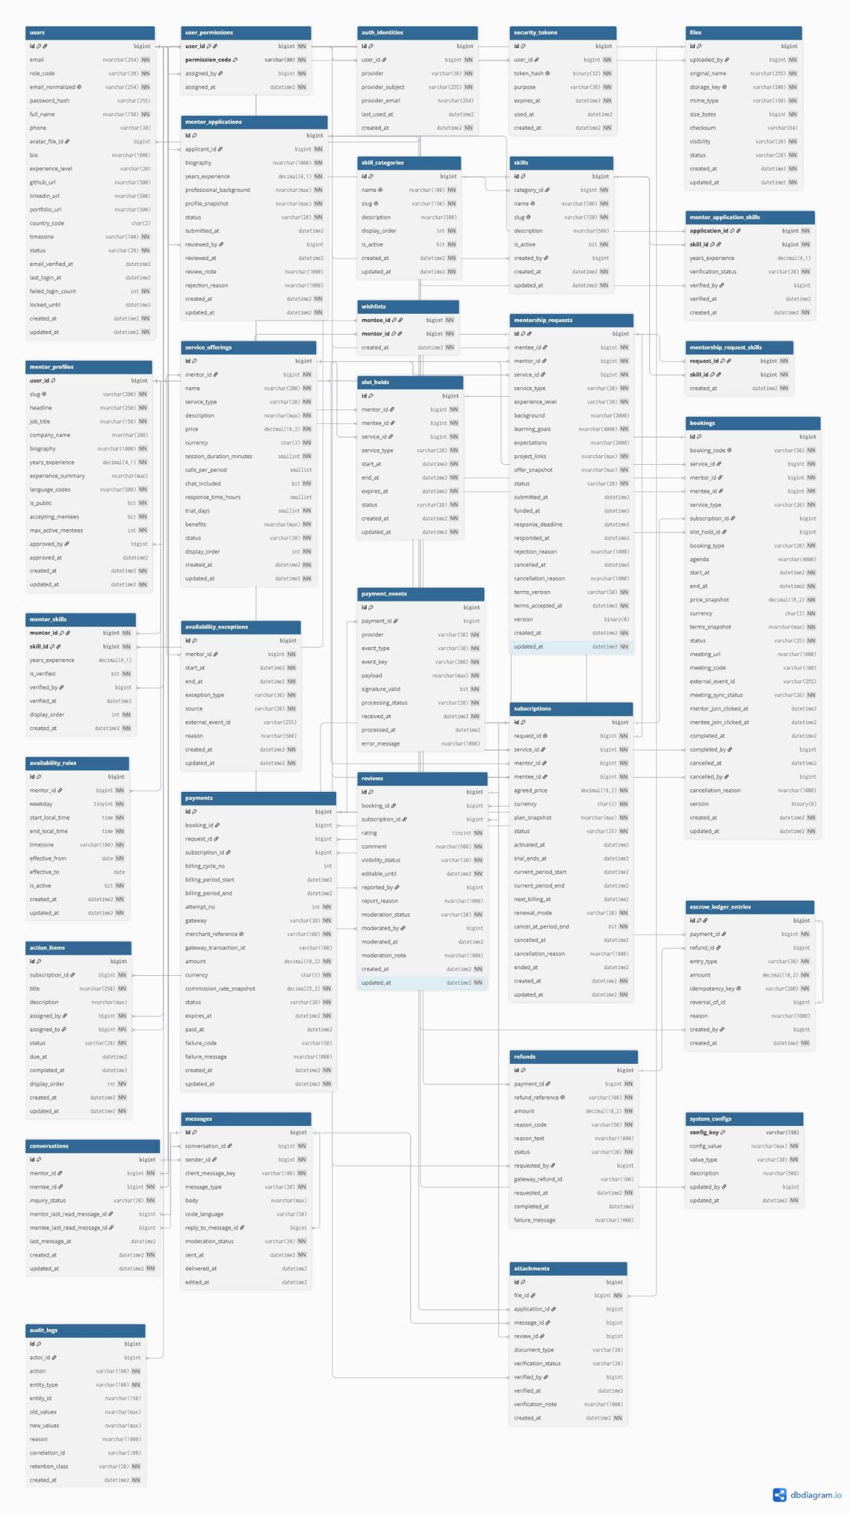

1.3.1 users

No | Field | PK | FK | UN | NN | Description
01 | id | X |  |  | X | Unique identifier of this record.
02 | email |  |  |  | X | Email address used for account contact and sign-in.
03 | role_code |  |  |  | X | Single role assigned to this account. Values: ADMIN, STAFF, MENTOR, MENTEE.
04 | email_normalized |  |  | X |  | Persisted computed value: lower-case email with surrounding spaces removed. Used to enforce email uniqueness.
05 | password_hash |  |  |  |  | Password hash used for local authentication; may be empty for an account using external sign-in.
06 | full_name |  |  |  | X | Full name displayed for the user.
07 | phone |  |  |  |  | Contact phone number.
08 | avatar_file_id |  | X |  |  | Uploaded file used as the profile picture. References files.id.
09 | bio |  |  |  |  | Short personal biography.
10 | experience_level |  |  |  |  | Declared programming experience level. Values: BEGINNER, JUNIOR, MID, SENIOR.
11 | github_url |  |  |  |  | URL of the user’s GitHub profile.
12 | linkedin_url |  |  |  |  | URL of the user’s LinkedIn profile.
13 | portfolio_url |  |  |  |  | URL of the user’s portfolio.
14 | country_code |  |  |  |  | Two-character country code.
15 | timezone |  |  |  | X | Time zone used to interpret local time and display schedules.
16 | status |  |  |  | X | Current lifecycle status of this record. Values: ACTIVE, INACTIVE, LOCKED.
17 | email_verified_at |  |  |  |  | Time when the email address was verified.
18 | last_login_at |  |  |  |  | Time of the most recent successful login.
19 | failed_login_count |  |  |  | X | Number of failed login attempts used by the account lock policy.
20 | locked_until |  |  |  |  | Time when a temporary account lock expires.
21 | created_at |  |  |  | X | Time when the record was created.
22 | updated_at |  |  |  | X | Time of the latest record update.
Email uniqueness is enforced on email_normalized, not directly on email. This computed column has no explicit NOT NULL declaration.

1.3.2 user_permissions
No | Field | PK | FK | UN | NN | Description
01 | user_id | X | X |  | X | Staff user receiving the permission. References users.id.
02 | permission_code | X |  |  | X | Permission granted to the Staff account. Values: MENTOR_APPLICATION_MANAGE, MENTEE_MANAGE, MENTORSHIP_REQUEST_MANAGE, SKILL_MANAGE.
03 | assigned_by |  | X |  | X | Active Admin who granted the permission to the Staff user. References users.id.
04 | assigned_at |  |  |  | X | Time when the permission was granted.

1.3.3 auth_identities
No | Field | PK | FK | UN | NN | Description
01 | id | X |  |  | X | Unique identifier of this record.
02 | user_id |  | X |  | X | User account associated with this record. References users.id.
03 | provider |  |  |  | X | External provider name.
04 | provider_subject |  |  |  | X | Account identifier issued by the external provider.
05 | provider_email |  |  |  |  | Email address returned by the external provider.
06 | last_used_at |  |  |  |  | Time when this external identity was last used.
07 | created_at |  |  |  | X | Time when the record was created.
1.3.4 security_tokens
No | Field | PK | FK | UN | NN | Description
01 | id | X |  |  | X | Unique identifier of this record.
02 | user_id |  | X |  | X | User account associated with this record. References users.id.
03 | token_hash |  |  | X | X | Hash of the security token; the raw token is not stored.
04 | purpose |  |  |  | X | Operation for which the token is issued. Values: VERIFY_EMAIL, RESET_PASSWORD.
05 | expires_at |  |  |  | X | Time after which the record is no longer valid.
06 | used_at |  |  |  |  | Time when the token was consumed.
07 | created_at |  |  |  | X | Time when the record was created.

1.3.5 mentor_profiles
No | Field | PK | FK | UN | NN | Description
01 | user_id | X | X |  | X | User account owning this mentor profile; also the profile’s primary key. References users.id.
02 | slug |  |  | X | X | Readable identifier used in public URLs.
03 | headline |  |  |  | X | Short headline shown on the mentor profile.
04 | job_title |  |  |  | X | Mentor’s current professional title.
05 | company_name |  |  |  |  | Company or organisation associated with the mentor.
06 | biography |  |  |  | X | Professional biography supplied by the mentor.
07 | years_experience |  |  |  | X | Number of years of relevant experience.
08 | experience_summary |  |  |  |  | Summary of the mentor’s professional experience.
09 | language_codes |  |  |  | X | JSON array of languages supported by the mentor.
10 | is_public |  |  |  | X | Whether the mentor profile is publicly visible.
11 | accepting_mentees |  |  |  | X | Whether the mentor currently accepts new mentees.
12 | max_active_mentees |  |  |  | X | Maximum number of active mentees the mentor intends to support.
13 | approved_by |  | X |  |  | User who approved the mentor profile. References users.id.
14 | approved_at |  |  |  |  | Time when the mentor profile was approved.
15 | created_at |  |  |  | X | Time when the record was created.
16 | updated_at |  |  |  | X | Time of the latest record update.
1.3.6 files
No | Field | PK | FK | UN | NN | Description
01 | id | X |  |  | X | Unique identifier of this record.
02 | uploaded_by |  | X |  | X | User who uploaded the file. References users.id.
03 | original_name |  |  |  | X | Original filename supplied during upload.
04 | storage_key |  |  | X | X | Unique object-storage key identifying the uploaded file.
05 | mime_type |  |  |  | X | Media type of the uploaded file.
06 | size_bytes |  |  |  | X | File size in bytes.
07 | checksum |  |  |  |  | Checksum used to verify file integrity.
08 | visibility |  |  |  | X | File access visibility classification. Values: PRIVATE, AUTHORIZED, PUBLIC.
09 | status |  |  |  | X | Upload lifecycle state. A file must be READY before it can be attached. Values: UPLOADING, READY, QUARANTINED, DELETED.
10 | created_at |  |  |  | X | Time when the record was created.
11 | updated_at |  |  |  | X | Time of the latest record update.

1.3.7 mentor_applications
No | Field | PK | FK | UN | NN | Description
01 | id | X |  |  | X | Unique identifier of this record.
02 | applicant_id |  | X |  | X | User applying to become a mentor. References users.id.
03 | biography |  |  |  | X | Professional biography supplied by the mentor.
04 | years_experience |  |  |  | X | Number of years of relevant experience.
05 | professional_background |  |  |  | X | Professional background submitted in the mentor application.
06 | profile_snapshot |  |  |  | X | JSON object preserving the submitted profile information.
07 | status |  |  |  | X | Current lifecycle status of this record. Values: DRAFT, PENDING, APPROVED, REJECTED, WITHDRAWN.
08 | submitted_at |  |  |  |  | Time when the application or request was submitted.
09 | reviewed_by |  | X |  |  | User who reviewed the mentor application. References users.id.
10 | reviewed_at |  |  |  |  | Time when the application was reviewed.
11 | review_note |  |  |  |  | Internal note about the application review.
12 | rejection_reason |  |  |  |  | Reason provided when the application or request is rejected.
13 | created_at |  |  |  | X | Time when the record was created.
14 | updated_at |  |  |  | X | Time of the latest record update.

1.3.8 skill_categories
No | Field | PK | FK | UN | NN | Description
01 | id | X |  |  | X | Unique identifier of this record.
02 | name |  |  | X | X | Display name.
03 | slug |  |  | X | X | Readable identifier used in public URLs.
04 | description |  |  |  |  | Description of this record.
05 | display_order |  |  |  | X | Position used when displaying records in a list.
06 | is_active |  |  |  | X | Whether the record is enabled for use.
07 | created_at |  |  |  | X | Time when the record was created.
08 | updated_at |  |  |  | X | Time of the latest record update.

1.3.9 skills

No | Field | PK | FK | UN | NN | Description
01 | id | X |  |  | X | Unique identifier of this record.
02 | category_id |  | X |  | X | Skill category containing this skill. References skill_categories.id.
03 | name |  |  | X | X | Display name.
04 | slug |  |  | X | X | Readable identifier used in public URLs.
05 | description |  |  |  |  | Description of this record.
06 | is_active |  |  |  | X | Whether the record is enabled for use.
07 | created_by |  | X |  |  | User who created the record; may be absent for a system operation. References users.id.
08 | created_at |  |  |  | X | Time when the record was created.
09 | updated_at |  |  |  | X | Time of the latest record update.

1.3.10 mentor_application_skills

No | Field | PK | FK | UN | NN | Description
01 | application_id | X | X |  | X | Mentor application associated with this record. References mentor_applications.id.
02 | skill_id | X | X |  | X | Skill associated with this record. References skills.id.
03 | years_experience |  |  |  |  | Experience claimed for this skill in the submitted application.
04 | verification_status |  |  |  | X | Result or progress of verification.
05 | verified_by |  | X |  |  | User who verified the submitted information. References users.id.
06 | verified_at |  |  |  |  | Time when verification was performed.
07 | created_at |  |  |  | X | Time when the record was created.

1.3.11 mentor_skills

No | Field | PK | FK | UN | NN | Description
01 | mentor_id | X | X |  | X | Mentor associated with this record. References mentor_profiles.user_id.
02 | skill_id | X | X |  | X | Skill associated with this record. References skills.id.
03 | years_experience |  |  |  |  | Mentor’s years of experience with this skill.
04 | is_verified |  |  |  | X | Whether the mentor’s skill has been verified.
05 | verified_by |  | X |  |  | User who verified the submitted information. References users.id.
06 | verified_at |  |  |  |  | Time when verification was performed.
07 | display_order |  |  |  | X | Position used when displaying records in a list.
08 | created_at |  |  |  | X | Time when the record was created.

1.3.12 service_offerings

No | Field | PK | FK | UN | NN | Description
01 | id | X |  |  | X | Unique identifier of this record.
02 | mentor_id |  | X |  | X | Mentor associated with this record. References mentor_profiles.user_id.
03 | name |  |  |  | X | Display name.
04 | service_type |  |  |  | X | Type of mentorship service. Values: MONTHLY, ONE_OFF.
05 | description |  |  |  | X | Description of this record.
06 | price |  |  |  | X | Price charged for the service offering.
07 | currency |  |  |  | X | Three-character currency code used for monetary amounts.
08 | session_duration_minutes |  |  |  | X | Duration of a scheduled call in minutes.
09 | calls_per_period |  |  |  |  | Number of calls included in a monthly billing period.
10 | chat_included |  |  |  | X | Whether chat support is included in the offering.
11 | response_time_hours |  |  |  |  | Promised chat response time in hours.
12 | trial_days |  |  |  | X | Number of trial days configured for the offering.
13 | benefits |  |  |  | X | JSON array describing the benefits included in the offering.
14 | status |  |  |  | X | Current lifecycle status of this record. Values: DRAFT, ACTIVE, INACTIVE.
15 | display_order |  |  |  | X | Position used when displaying records in a list.
16 | created_at |  |  |  | X | Time when the record was created.
17 | updated_at |  |  |  | X | Time of the latest record update.

1.3.13 wishlists

No | Field | PK | FK | UN | NN | Description
01 | mentee_id | X | X |  | X | Mentee associated with this record. References users.id.
02 | mentor_id | X | X |  | X | Mentor associated with this record. References mentor_profiles.user_id.
03 | created_at |  |  |  | X | Time when the record was created.
Composite primary key: (mentee_id, mentor_id).

1.3.14 mentorship_requests

No | Field | PK | FK | UN | NN | Description
01 | id | X |  |  | X | Unique identifier of this record.
02 | mentee_id |  | X |  | X | Mentee associated with this record. References users.id.
03 | mentor_id |  | X |  | X | Mentor associated with this record. References service_offerings.mentor_id.
04 | service_id |  | X |  | X | Service offering selected for this record. References service_offerings.id.
05 | service_type |  | X |  | X | Type of mentorship service. References service_offerings.service_type.
06 | experience_level |  |  |  | X | Declared programming experience level. Values: BEGINNER, JUNIOR, MID, SENIOR.
07 | background |  |  |  |  | Mentee’s background relevant to the mentorship request.
08 | learning_goals |  |  |  | X | Learning goals supplied by the mentee; at least 50 characters after trimming.
09 | expectations |  |  |  |  | Mentee’s expectations of the mentor and mentorship.
10 | project_links |  |  |  | X | JSON array of links to the mentee’s projects.
11 | offer_snapshot |  |  |  | X | JSON object preserving the offering terms submitted with the request.
12 | status |  |  |  | X | Current lifecycle status of this record. Values: DRAFT, PENDING_PAYMENT, PENDING, ACCEPTED, REJECTED, EXPIRED, CANCELLED.
13 | submitted_at |  |  |  |  | Time when the application or request was submitted.
14 | funded_at |  |  |  |  | Time of the successful initial payment linked to the request’s escrow hold.
15 | response_deadline |  |  |  |  | Deadline for the mentor to respond after funding.
16 | responded_at |  |  |  |  | Time when the mentor accepted or rejected the request.
17 | rejection_reason |  |  |  |  | Reason provided when the application or request is rejected.
18 | cancelled_at |  |  |  |  | Time when cancellation was recorded.
19 | cancellation_reason |  |  |  |  | Reason for cancelling the request, subscription, or booking.
20 | terms_version |  |  |  | X | Identifier of the terms accepted by the mentee.
21 | terms_accepted_at |  |  |  | X | Time when the mentee accepted the terms.
22 | version |  |  |  | X | SQL Server ROWVERSION value used for optimistic concurrency; not a date or time.
23 | created_at |  |  |  | X | Time when the record was created.
24 | updated_at |  |  |  | X | Time of the latest record update.

1.3.15 mentorship_request_skills

No | Field | PK | FK | UN | NN | Description
01 | request_id | X | X |  | X | Monthly mentorship request associated with this record. References mentorship_requests.id.
02 | skill_id | X | X |  | X | Skill associated with this record. References skills.id.
03 | created_at |  |  |  | X | Time when the record was created.

1.3.16 availability_rules
No | Field | PK | FK | UN | NN | Description
01 | id | X |  |  | X | Unique identifier of this record.
02 | mentor_id |  | X |  | X | Mentor associated with this record. References mentor_profiles.user_id.
03 | weekday |  |  |  | X | Day of the week, stored as a number from 1 to 7.
04 | start_local_time |  |  |  | X | Local time when the availability interval starts.
05 | end_local_time |  |  |  | X | Local time when the availability interval ends.
06 | timezone |  |  |  | X | Time zone used to interpret local time and display schedules.
07 | effective_from |  |  |  | X | First date on which the availability rule applies.
08 | effective_to |  |  |  |  | Last date on which the rule applies; empty for an open-ended rule.
09 | is_active |  |  |  | X | Whether the record is enabled for use.
10 | created_at |  |  |  | X | Time when the record was created.
11 | updated_at |  |  |  | X | Time of the latest record update.

1.3.17 availability_exceptions

No | Field | PK | FK | UN | NN | Description
01 | id | X |  |  | X | Unique identifier of this record.
02 | mentor_id |  | X |  | X | Mentor associated with this record. References mentor_profiles.user_id.
03 | start_at |  |  |  | X | Start time of the scheduled interval.
04 | end_at |  |  |  | X | End time of the scheduled interval.
05 | exception_type |  |  |  | X | Whether the exception adds availability or blocks time. Values: BLOCKED, EXTRA_AVAILABLE.
06 | source |  |  |  | X | Origin of the availability exception. Values: MANUAL, GOOGLE.
07 | external_event_id |  |  |  |  | Identifier of the event in the external calendar service.
08 | reason |  |  |  |  | Explanation for the operation or record.
09 | created_at |  |  |  | X | Time when the record was created.
10 | updated_at |  |  |  | X | Time of the latest record update.

1.3.18 slot_holds

No | Field | PK | FK | UN | NN | Description
01 | id | X |  |  | X | Unique identifier of this record.
02 | mentor_id |  | X |  | X | Mentor associated with this record. References service_offerings.mentor_id.
03 | mentee_id |  | X |  | X | Mentee associated with this record. References users.id.
04 | service_id |  | X |  | X | Service offering selected for this record. References service_offerings.id.
05 | service_type |  | X |  | X | Type of mentorship service. References service_offerings.service_type.
06 | start_at |  |  |  | X | Start time of the scheduled interval.
07 | end_at |  |  |  | X | End time of the scheduled interval.
08 | expires_at |  |  |  | X | Time after which the record is no longer valid.
09 | status |  |  |  | X | Current lifecycle status of this record. Values: HELD, CONVERTED, RELEASED, EXPIRED.
10 | created_at |  |  |  | X | Time when the record was created.
11 | updated_at |  |  |  | X | Time of the latest record update.

1.3.19 subscriptions

No | Field | PK | FK | UN | NN | Description
01 | id | X |  |  | X | Unique identifier of this record.
02 | request_id |  | X | X | X | Accepted and funded request from which this subscription was created. References mentorship_requests.id.
03 | service_id |  | X |  | X | Service offering selected for this record. References mentorship_requests.service_id.
04 | mentor_id |  | X |  | X | Mentor associated with this record. References mentorship_requests.mentor_id.
05 | mentee_id |  | X |  | X | Mentee associated with this record. References mentorship_requests.mentee_id.
06 | agreed_price |  |  |  | X | Agreed monthly price stored for the subscription.
07 | currency |  |  |  | X | Three-character currency code used for monetary amounts.
08 | plan_snapshot |  |  |  | X | JSON object preserving the agreed monthly plan.
09 | status |  |  |  | X | Current lifecycle status of this record. Values: TRIALING, ACTIVE, PAST_DUE, CANCELLED, ENDED.
10 | activated_at |  |  |  |  | Time when the subscription was activated.
11 | trial_ends_at |  |  |  |  | Time when the subscription trial ends.
12 | current_period_start |  |  |  |  | Start of the current subscription billing period.
13 | current_period_end |  |  |  |  | End of the current subscription billing period.
14 | next_billing_at |  |  |  |  | Time scheduled for the next renewal payment.
15 | renewal_mode |  |  |  | X | Renewal mechanism configured for this subscription. Values: MANUAL, AUTOMATIC.
16 | cancel_at_period_end |  |  |  | X | Whether the subscription should end at the current period boundary.
17 | cancelled_at |  |  |  |  | Time when cancellation was recorded.
18 | cancellation_reason |  |  |  |  | Reason for cancelling the request, subscription, or booking.
19 | ended_at |  |  |  |  | Time when the subscription ended.
20 | created_at |  |  |  | X | Time when the record was created.
21 | updated_at |  |  |  | X | Time of the latest record update.

1.3.20 bookings

No | Field | PK | FK | UN | NN | Description
01 | id | X |  |  | X | Unique identifier of this record.
02 | booking_code |  |  | X | X | Unique booking reference displayed to users.
03 | service_id |  | X |  | X | Service offering selected for this record. References service_offerings.id, subscriptions.service_id, slot_holds.service_id.
04 | mentor_id |  | X |  | X | Mentor associated with this record. References service_offerings.mentor_id, subscriptions.mentor_id, slot_holds.mentor_id.
05 | mentee_id |  | X |  | X | Mentee associated with this record. References users.id, subscriptions.mentee_id, slot_holds.mentee_id.
06 | service_type |  | X |  | X | Type of mentorship service. References service_offerings.service_type.
07 | subscription_id |  | X |  |  | Subscription covering an included monthly call; empty for a one-off booking. References subscriptions.id.
08 | slot_hold_id |  | X |  |  | Temporary reservation converted into this booking. References slot_holds.id.
09 | booking_type |  |  |  | X | Whether this is a one-off session or a call included in a monthly subscription.
10 | agenda |  |  |  |  | Topics or goals to discuss during the session.
11 | start_at |  |  |  | X | Start time of the scheduled interval.
12 | end_at |  |  |  | X | End time of the scheduled interval.
13 | price_snapshot |  |  |  | X | Service price preserved when the booking was created.
14 | currency |  |  |  | X | Three-character currency code used for monetary amounts.
15 | terms_snapshot |  |  |  | X | JSON object preserving the booking terms.
16 | status |  |  |  | X | Current lifecycle status of this record. Values: PENDING_PAYMENT, CONFIRMED, COMPLETED, CANCELLED, EXPIRED, NO_SHOW_REVIEW, NO_SHOW.
17 | meeting_url |  |  |  |  | Full URL used to join the online meeting.
18 | meeting_code |  |  |  |  | Google Meet conference code, for example abc-defg-hij.
19 | external_event_id |  |  |  |  | Identifier of the event in the external calendar service.
20 | meeting_sync_status |  |  |  | X | Status of calendar and meeting synchronisation. Values: PENDING, SYNCED, FAILED.
21 | mentor_join_clicked_at |  |  |  |  | Time when the mentor clicked Join; does not prove attendance.
22 | mentee_join_clicked_at |  |  |  |  | Time when the mentee clicked Join; does not prove attendance.
23 | completed_at |  |  |  |  | Time when completion was recorded.
24 | completed_by |  | X |  |  | User who marked the booking as completed. References users.id.
25 | cancelled_at |  |  |  |  | Time when cancellation was recorded.
26 | cancelled_by |  | X |  |  | User who cancelled the booking. References users.id.
27 | cancellation_reason |  |  |  |  | Reason for cancelling the request, subscription, or booking.
28 | version |  |  |  | X | SQL Server ROWVERSION value used for optimistic concurrency; not a date or time.
29 | created_at |  |  |  | X | Time when the record was created.
30 | updated_at |  |  |  | X | Time of the latest record update.

1.3.21 action_items

No | Field | PK | FK | UN | NN | Description
01 | id | X |  |  | X | Unique identifier of this record.
02 | subscription_id |  | X |  | X | Monthly subscription associated with this record. References subscriptions.id.
03 | title |  |  |  | X | Title of the learning task.
04 | description |  |  |  |  | Description of this record.
05 | assigned_by |  | X |  | X | User who assigned this record. References users.id.
06 | assigned_to |  | X |  | X | User responsible for completing the learning task. References users.id.
07 | status |  |  |  | X | Current lifecycle status of this record. Values: TODO, IN_PROGRESS, DONE.
08 | due_at |  |  |  |  | Deadline for completing the task.
09 | completed_at |  |  |  |  | Time when completion was recorded.
10 | display_order |  |  |  | X | Position used when displaying records in a list.
11 | created_at |  |  |  | X | Time when the record was created.
12 | updated_at |  |  |  | X | Time of the latest record update.

1.3.22 payments

No | Field | PK | FK | UN | NN | Description
01 | id | X |  |  | X | Unique identifier of this record.
02 | booking_id |  | X |  |  | One-off booking being paid for; empty for monthly payments. References bookings.id.
03 | request_id |  | X |  |  | Monthly request funded before mentor review; used for the first billing cycle. References mentorship_requests.id.
04 | subscription_id |  | X |  |  | Existing subscription being renewed; used from billing cycle 2 onward. References subscriptions.id.
05 | billing_cycle_no |  |  |  |  | Monthly billing cycle number: 1 for initial funding, 2 or higher for renewals; empty for one-off payments.
06 | billing_period_start |  |  |  |  | Start of the period covered by this payment; may be empty before initial subscription activation.
07 | billing_period_end |  |  |  |  | End of the period covered by this payment; supplied together with the period start.
08 | attempt_no |  |  |  | X | Positive attempt number for the payment target or billing cycle.
09 | gateway |  |  |  | X | Payment gateway handling the transaction.
10 | merchant_reference |  |  | X | X | Unique payment reference generated by the platform.
11 | gateway_transaction_id |  |  |  |  | Transaction identifier returned by the payment gateway.
12 | amount |  |  |  | X | Monetary amount of this record.
13 | currency |  |  |  | X | Three-character currency code used for monetary amounts.
14 | commission_rate_snapshot |  |  |  | X | Platform commission percentage captured for this payment, from 0 to 100. Existing snapshots remain unchanged when configuration changes.
15 | status |  |  |  | X | Current lifecycle status of this record. Values: PENDING, SUCCEEDED, FAILED, CANCELLED, EXPIRED.
16 | expires_at |  |  |  | X | Deadline for completing this payment attempt.
17 | paid_at |  |  |  |  | Time when payment success was confirmed.
18 | failure_code |  |  |  |  | Failure code returned during payment processing.
19 | failure_message |  |  |  |  | Explanation of a failed payment or refund.
20 | created_at |  |  |  | X | Time when the record was created.
21 | updated_at |  |  |  | X | Time of the latest record update.

1.3.23 payment_events

No | Field | PK | FK | UN | NN | Description
01 | id | X |  |  | X | Unique identifier of this record.
02 | payment_id |  | X |  |  | Payment associated with this record. References payments.id.
03 | provider |  |  |  | X | External provider name.
04 | event_type |  |  |  | X | Type of payment notification received.
05 | event_key |  |  |  | X | Provider event identifier used to detect duplicate notifications.
06 | payload |  |  |  | X | JSON payload received from the payment provider.
07 | signature_valid |  |  |  | X | Whether the notification signature was verified.
08 | processing_status |  |  |  | X | Processing state of the notification. Values: RECEIVED, PROCESSED, REJECTED, ERROR.
09 | received_at |  |  |  | X | Time when the notification was received.
10 | processed_at |  |  |  |  | Time when notification processing finished.
11 | error_message |  |  |  |  | Error recorded while processing the notification.

1.3.24 refunds

No | Field | PK | FK | UN | NN | Description
01 | id | X |  |  | X | Unique identifier of this record.
02 | payment_id |  | X |  | X | Payment associated with this record. References payments.id.
03 | refund_reference |  |  | X | X | Unique refund reference generated by the platform.
04 | amount |  |  |  | X | Monetary amount of this record.
05 | reason_code |  |  |  | X | Code classifying the refund reason.
06 | reason_text |  |  |  |  | Additional explanation of the refund request.
07 | status |  |  |  | X | Current lifecycle status of this record. Values: PENDING, PROCESSING, SUCCEEDED, FAILED, CANCELLED.
08 | requested_by |  | X |  |  | User who requested the refund; may be absent for an automatic refund. References users.id.
09 | gateway_refund_id |  |  |  |  | Refund identifier returned by the payment gateway.
10 | requested_at |  |  |  | X | Time when the refund was requested.
11 | completed_at |  |  |  |  | Time when completion was recorded.
12 | failure_message |  |  |  |  | Explanation of a failed payment or refund.

1.3.25 escrow_ledger_entries

No | Field | PK | FK | UN | NN | Description
01 | id | X |  |  | X | Unique identifier of this record.
02 | payment_id |  | X |  | X | Payment associated with this record. References payments.id, refunds.payment_id, escrow_ledger_entries.payment_id.
03 | refund_id |  | X |  |  | Refund linked to an escrow refund-out entry. References refunds.id.
04 | entry_type |  | X |  | X | Type of escrow movement. Values: HOLD, REFUND_OUT, MENTOR_RELEASE, PLATFORM_FEE. References escrow_ledger_entries.entry_type.
05 | amount |  | X |  | X | Positive amount of this movement. A reversal uses the same amount and entry type as the original entry, with opposite accounting effect. References escrow_ledger_entries.amount.
06 | idempotency_key |  |  | X | X | Unique operation key that prevents duplicate ledger entries.
07 | reversal_of_id |  | X |  |  | Original entry reversed by this record; empty for an original entry. References escrow_ledger_entries.id.
08 | reason |  |  |  |  | Explanation for the operation or record.
09 | created_by |  | X |  |  | User who created the record; may be absent for a system operation. References users.id.
10 | created_at |  |  |  | X | Time when the record was created.

1.3.26 conversations

No | Field | PK | FK | UN | NN | Description
01 | id | X | X |  | X | Unique conversation identifier; also participates in foreign keys that keep read pointers inside this conversation. References messages.conversation_id.
02 | mentor_id |  | X |  | X | Mentor associated with this record. References mentor_profiles.user_id.
03 | mentee_id |  | X |  | X | Mentee associated with this record. References users.id.
04 | inquiry_status |  |  |  | X | Status of the initial mentor–mentee inquiry. Values: PENDING, APPROVED, REJECTED, CLOSED.
05 | mentor_last_read_message_id |  | X |  |  | Last message acknowledged as read by the mentor in this conversation. References messages.id.
06 | mentee_last_read_message_id |  | X |  |  | Last message acknowledged as read by the mentee in this conversation. References messages.id.
07 | last_message_at |  |  |  |  | Time of the latest message in the conversation.
08 | created_at |  |  |  | X | Time when the record was created.
09 | updated_at |  |  |  | X | Time of the latest record update.

1.3.27 messages

No | Field | PK | FK | UN | NN | Description
01 | id | X |  |  | X | Unique identifier of this record.
02 | conversation_id |  | X |  | X | Conversation containing the message. References conversations.id, messages.conversation_id.
03 | sender_id |  | X |  | X | User who sent the message. References users.id.
04 | client_message_key |  |  |  | X | Client-generated key for safely retrying message submission.
05 | message_type |  |  |  | X | Type of content carried by the message. Values: TEXT, CODE, FILE, SYSTEM.
06 | body |  |  |  |  | Text or code content of the message.
07 | code_language |  |  |  |  | Programming language used for a code message.
08 | reply_to_message_id |  | X |  |  | Message being replied to within the same conversation. References messages.id.
09 | moderation_status |  |  |  | X | Current moderation case status. Values: ALLOWED, BLOCKED, FLAGGED.
10 | sent_at |  |  |  | X | Time when the message was sent.
11 | delivered_at |  |  |  |  | Time when message delivery was acknowledged.
12 | edited_at |  |  |  |  | Time when the message content was last edited.

1.3.28 reviews

No | Field | PK | FK | UN | NN | Description
01 | id | X |  |  | X | Unique identifier of this record.
02 | booking_id |  | X |  |  | Completed booking being reviewed; empty when reviewing a monthly subscription. References bookings.id.
03 | subscription_id |  | X |  |  | Monthly subscription being reviewed; the current trigger allows ACTIVE or ENDED subscriptions. References subscriptions.id.
04 | rating |  |  |  | X | Star rating from 1 to 5.
05 | comment |  |  |  | X | Written review containing 10 to 500 characters after trimming.
06 | visibility_status |  |  |  | X | Public visibility state of the review. Values: PUBLISHED, HIDDEN, FLAGGED.
07 | editable_until |  |  |  | X | Deadline for editing the review; initially seven days after creation.
08 | reported_by |  | X |  |  | User who reported the review. References users.id.
09 | report_reason |  |  |  |  | Reason for reporting the review.
10 | moderation_status |  |  |  | X | Current moderation case status. Values: NONE, OPEN, RESOLVED, DISMISSED.
11 | moderated_by |  | X |  |  | User who handled the review moderation. References users.id.
12 | moderated_at |  |  |  |  | Time when moderation was performed.
13 | moderation_note |  |  |  |  | Note explaining the moderation decision.
14 | created_at |  |  |  | X | Time when the record was created.
15 | updated_at |  |  |  | X | Time of the latest record update.

1.3.29 attachments

No | Field | PK | FK | UN | NN | Description
01 | id | X |  |  | X | Unique identifier of this record.
02 | file_id |  | X |  | X | Uploaded file linked to the attachment. References files.id.
03 | application_id |  | X |  |  | Mentor application owning this document; empty for message or review attachments. References mentor_applications.id.
04 | message_id |  | X |  |  | Message owning this attachment. References messages.id.
05 | review_id |  | X |  |  | Review owning this evidence attachment. References reviews.id.
06 | document_type |  |  |  |  | Application document category; empty for message or review attachments.
07 | verification_status |  |  |  |  | Application-document verification state; required for application attachments and empty otherwise.
08 | verified_by |  | X |  |  | User who verified an application document; empty for other attachment types. References users.id.
09 | verified_at |  |  |  |  | Time of application-document verification; empty for other attachment types.
10 | verification_note |  |  |  |  | Note about application-document verification.
11 | created_at |  |  |  | X | Time when the record was created.

1.3.30 system_configs

No | Field | PK | FK | UN | NN | Description
01 | config_key | X |  |  | X | Unique key identifying a system setting.
02 | config_value |  |  |  | X | JSON object containing exactly one value property, for example {"value":15.00}. Its value must match value_type or be null.
03 | value_type |  |  |  | X | Type of the value inside the configuration JSON object. Values: STRING, NUMBER, BOOLEAN, JSON.
04 | description |  |  |  |  | Description of this record.
05 | updated_by |  | X |  |  | User who last changed the configuration. References users.id.
06 | updated_at |  |  |  | X | Time of the latest record update.

1.3.31 audit_logs
No | Field | PK | FK | UN | NN | Description
01 | id | X |  |  | X | Unique identifier of this record.
02 | actor_id |  | X |  |  | User who performed the logged action; may be absent for a system action. References users.id.
03 | action |  |  |  | X | Name or code of the recorded action.
04 | entity_type |  |  |  | X | Type of entity affected by the action.
05 | entity_id |  |  |  |  | Identifier of the affected entity; a generic reference without a foreign key.
06 | old_values |  |  |  |  | JSON object containing values before the change.
07 | new_values |  |  |  |  | JSON object containing values after the change.
08 | reason |  |  |  |  | Explanation for the operation or record.
09 | correlation_id |  |  |  |  | Identifier used to relate actions from the same request or workflow.
10 | retention_class |  |  |  | X | Classification used to apply the log retention policy. Values: BUSINESS, FINANCIAL, TECHNICAL.
11 | created_at |  |  |  | X | Time when the record was created.

2. State Transition Diagrams

2.1 PIN Validation

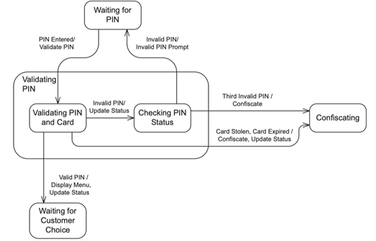

3. Detailed Design

3.1 Monthly mentorship booking and SePay Payment (Nguyễn Thị Ngọc Linh)

3.1.1 Class Diagram (Nguyễn Thị Ngọc Linh)

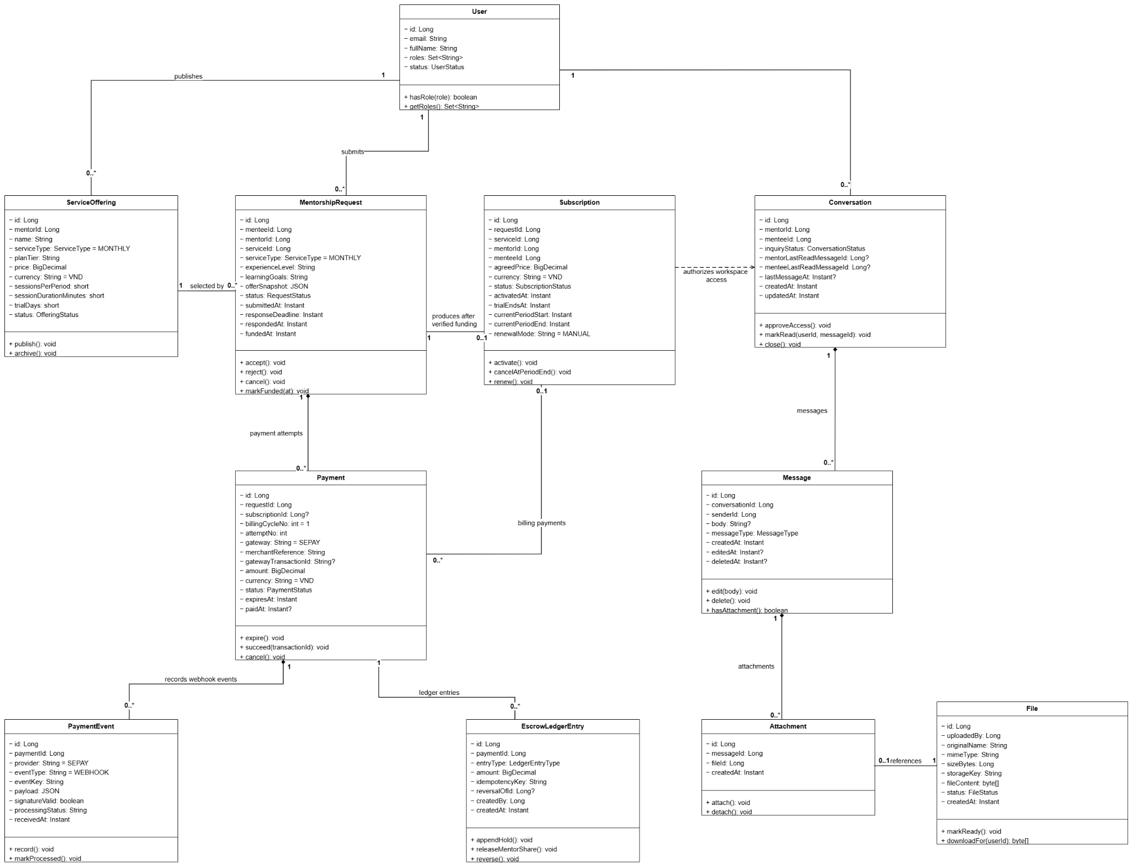

3.1.2 Submit Monthly Mentorship Request Sequence Diagram (Nguyễn Thị Ngọc Linh)

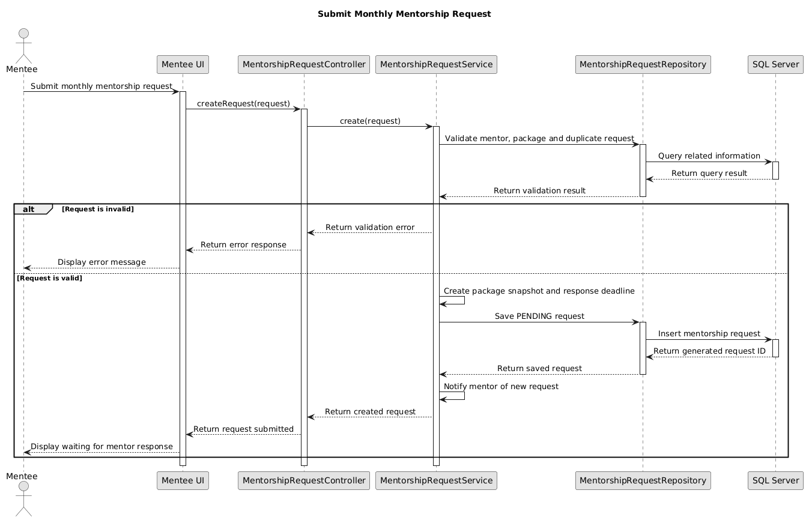

3.1.3 Review Monthly Mentorship Request Sequence Diagram (Nguyễn Thị Ngọc Linh)

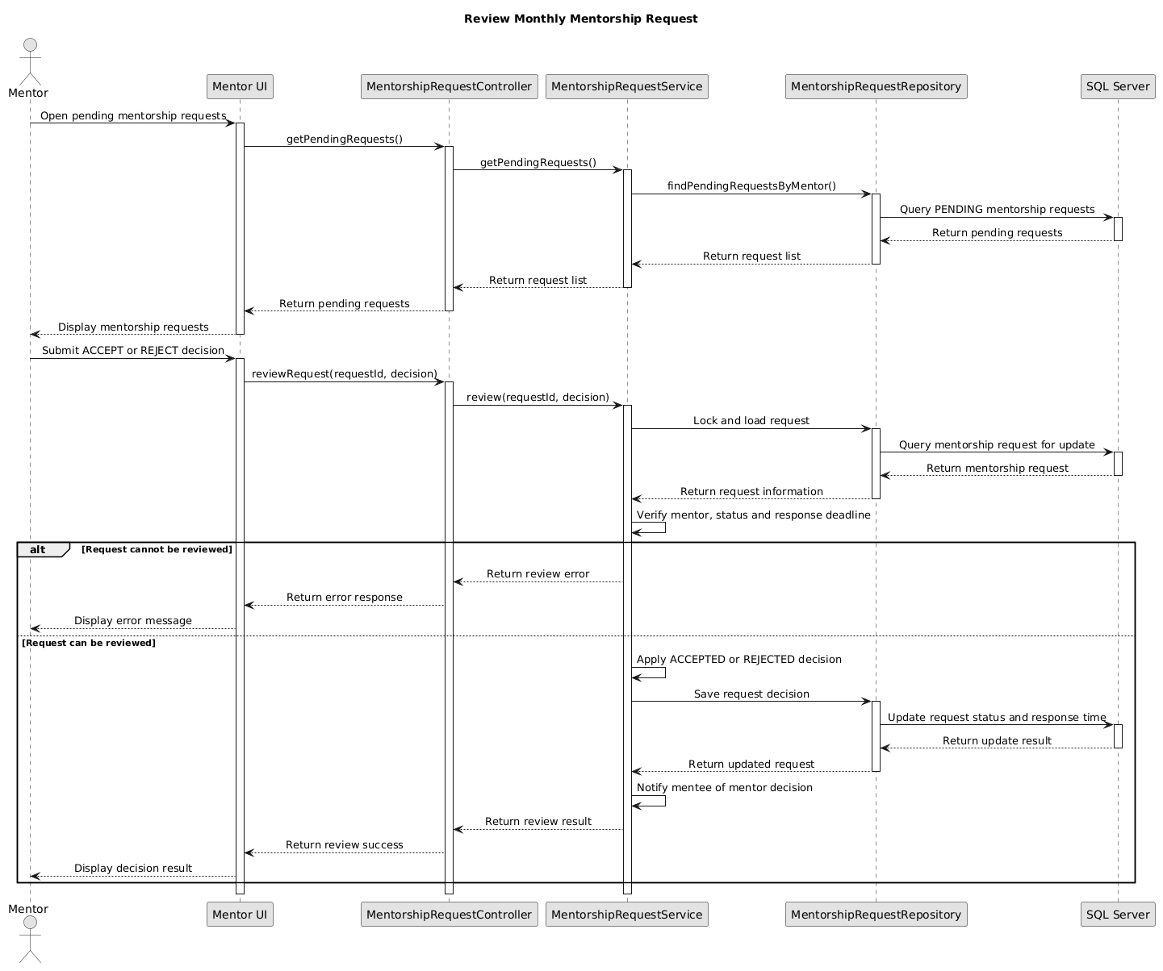

3.1.4 Process Monthly Mentorship Payment via SePay Sequence Diagram (Nguyễn Thị Ngọc Linh)

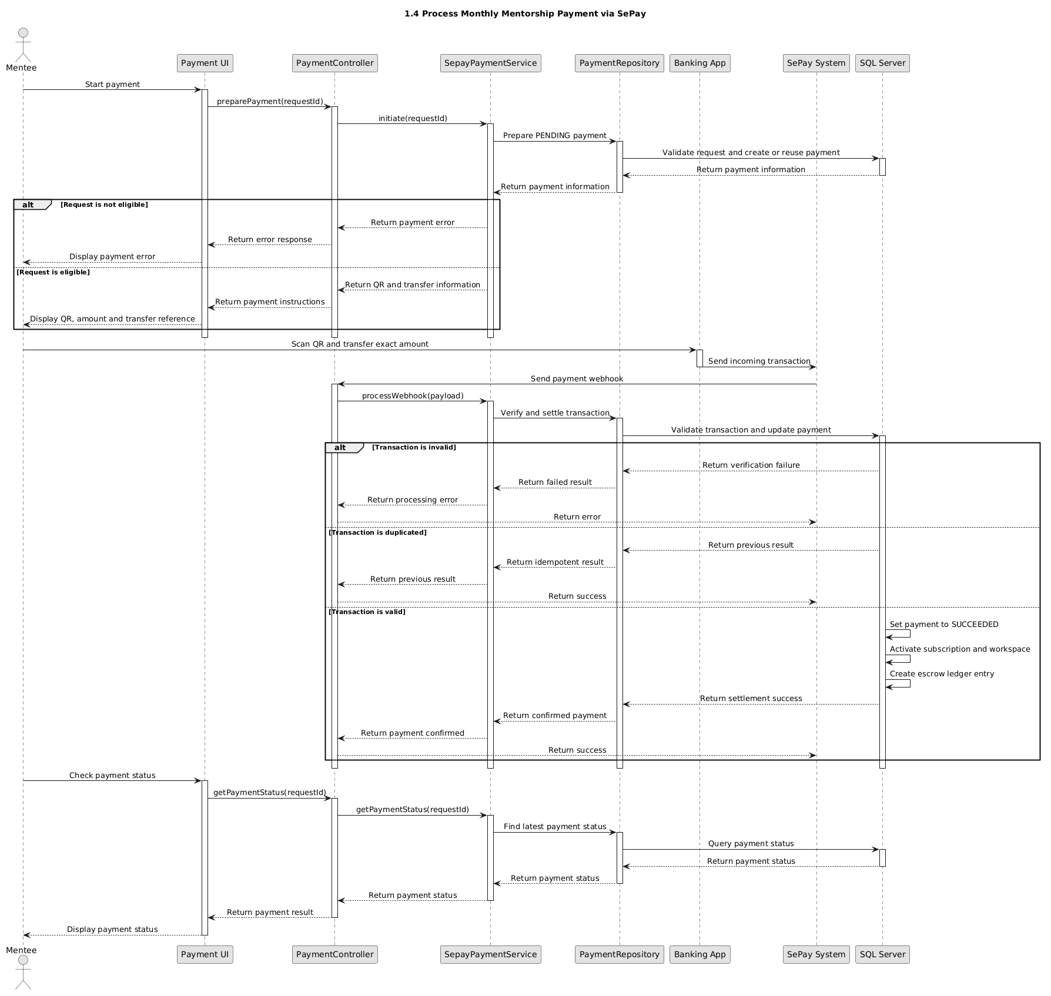

3.2 Account Status (Bùi Đức Lương)

3.2.1 Class diagram
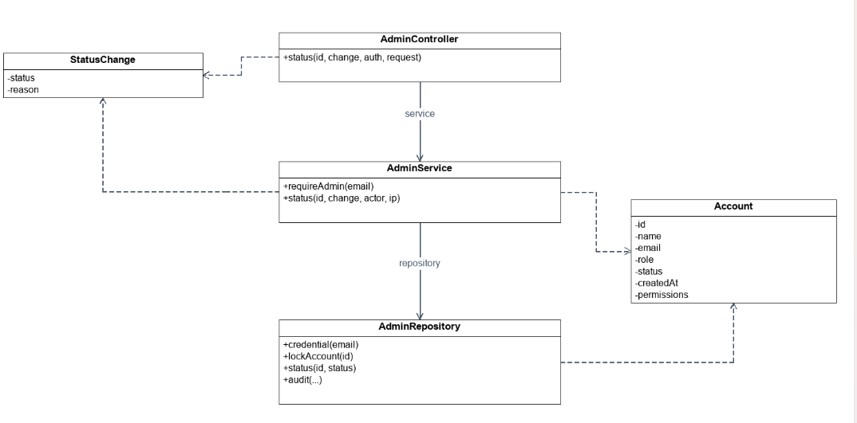

3.2.2 Sequence
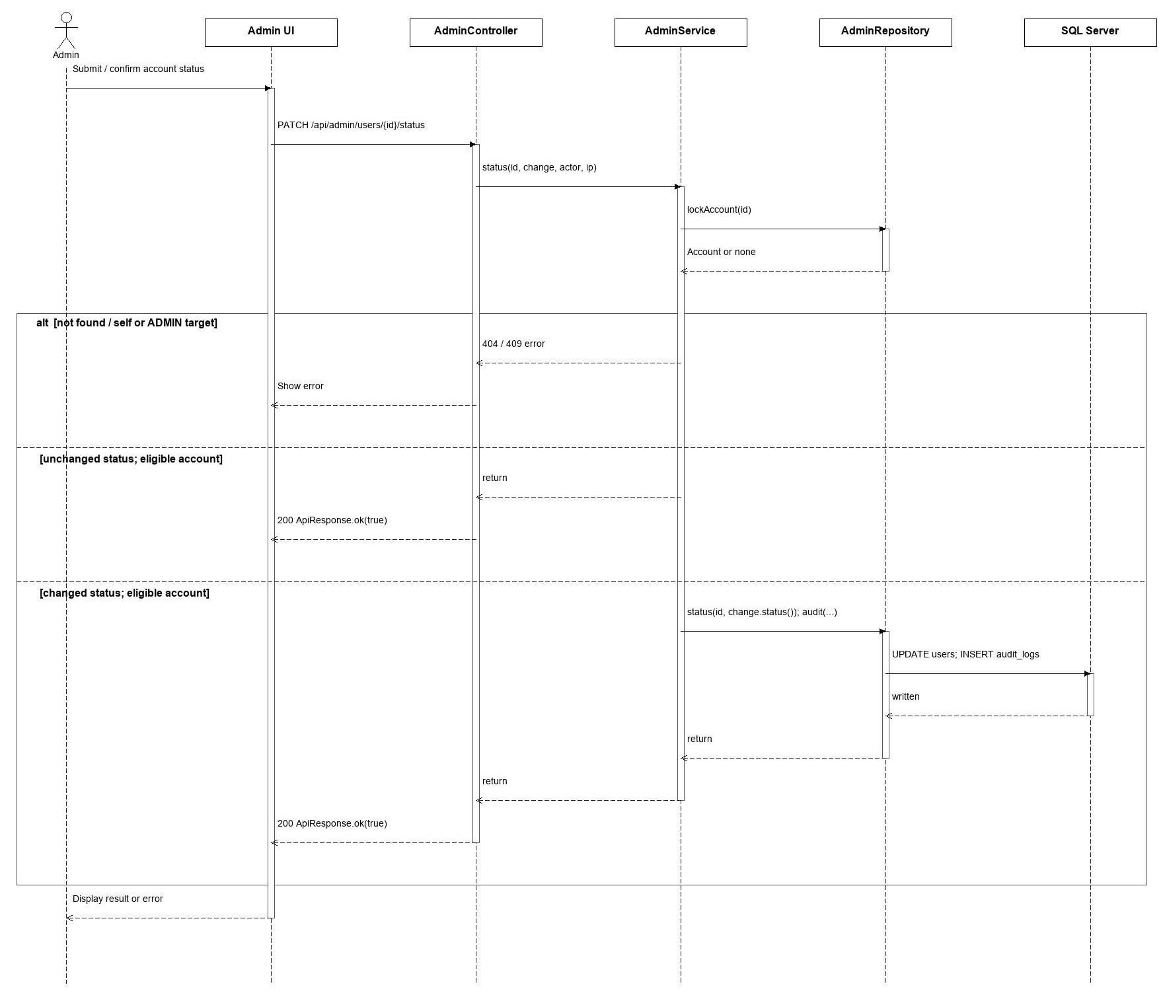

3.3 Staff Permission(Bùi Đức Lương)

3.3.1 Class diagram

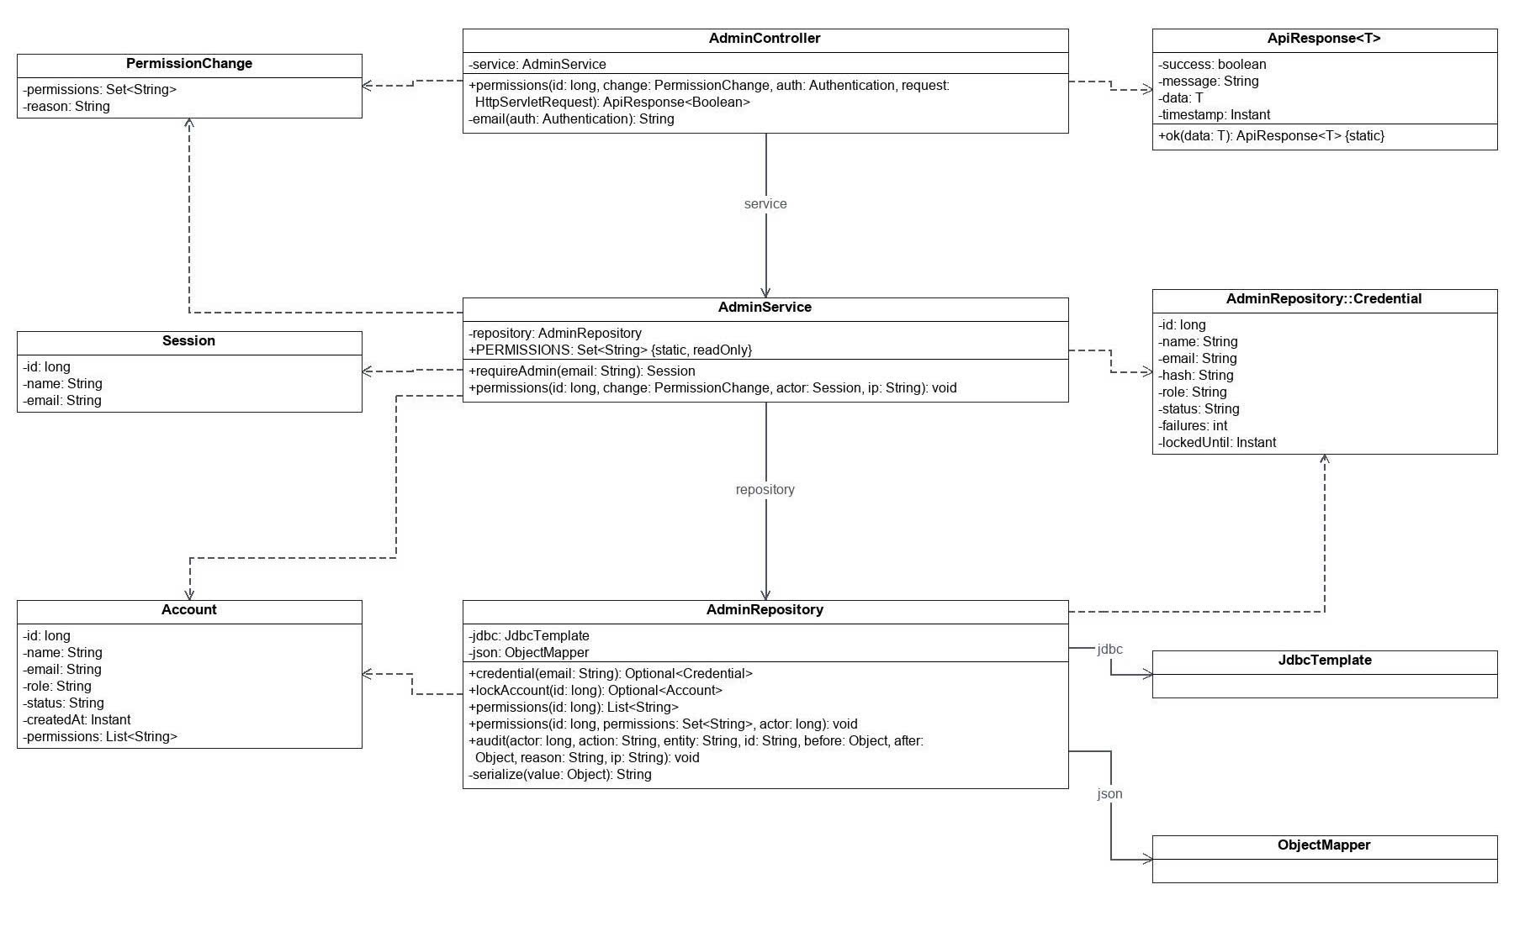

3.3.2 Sequence
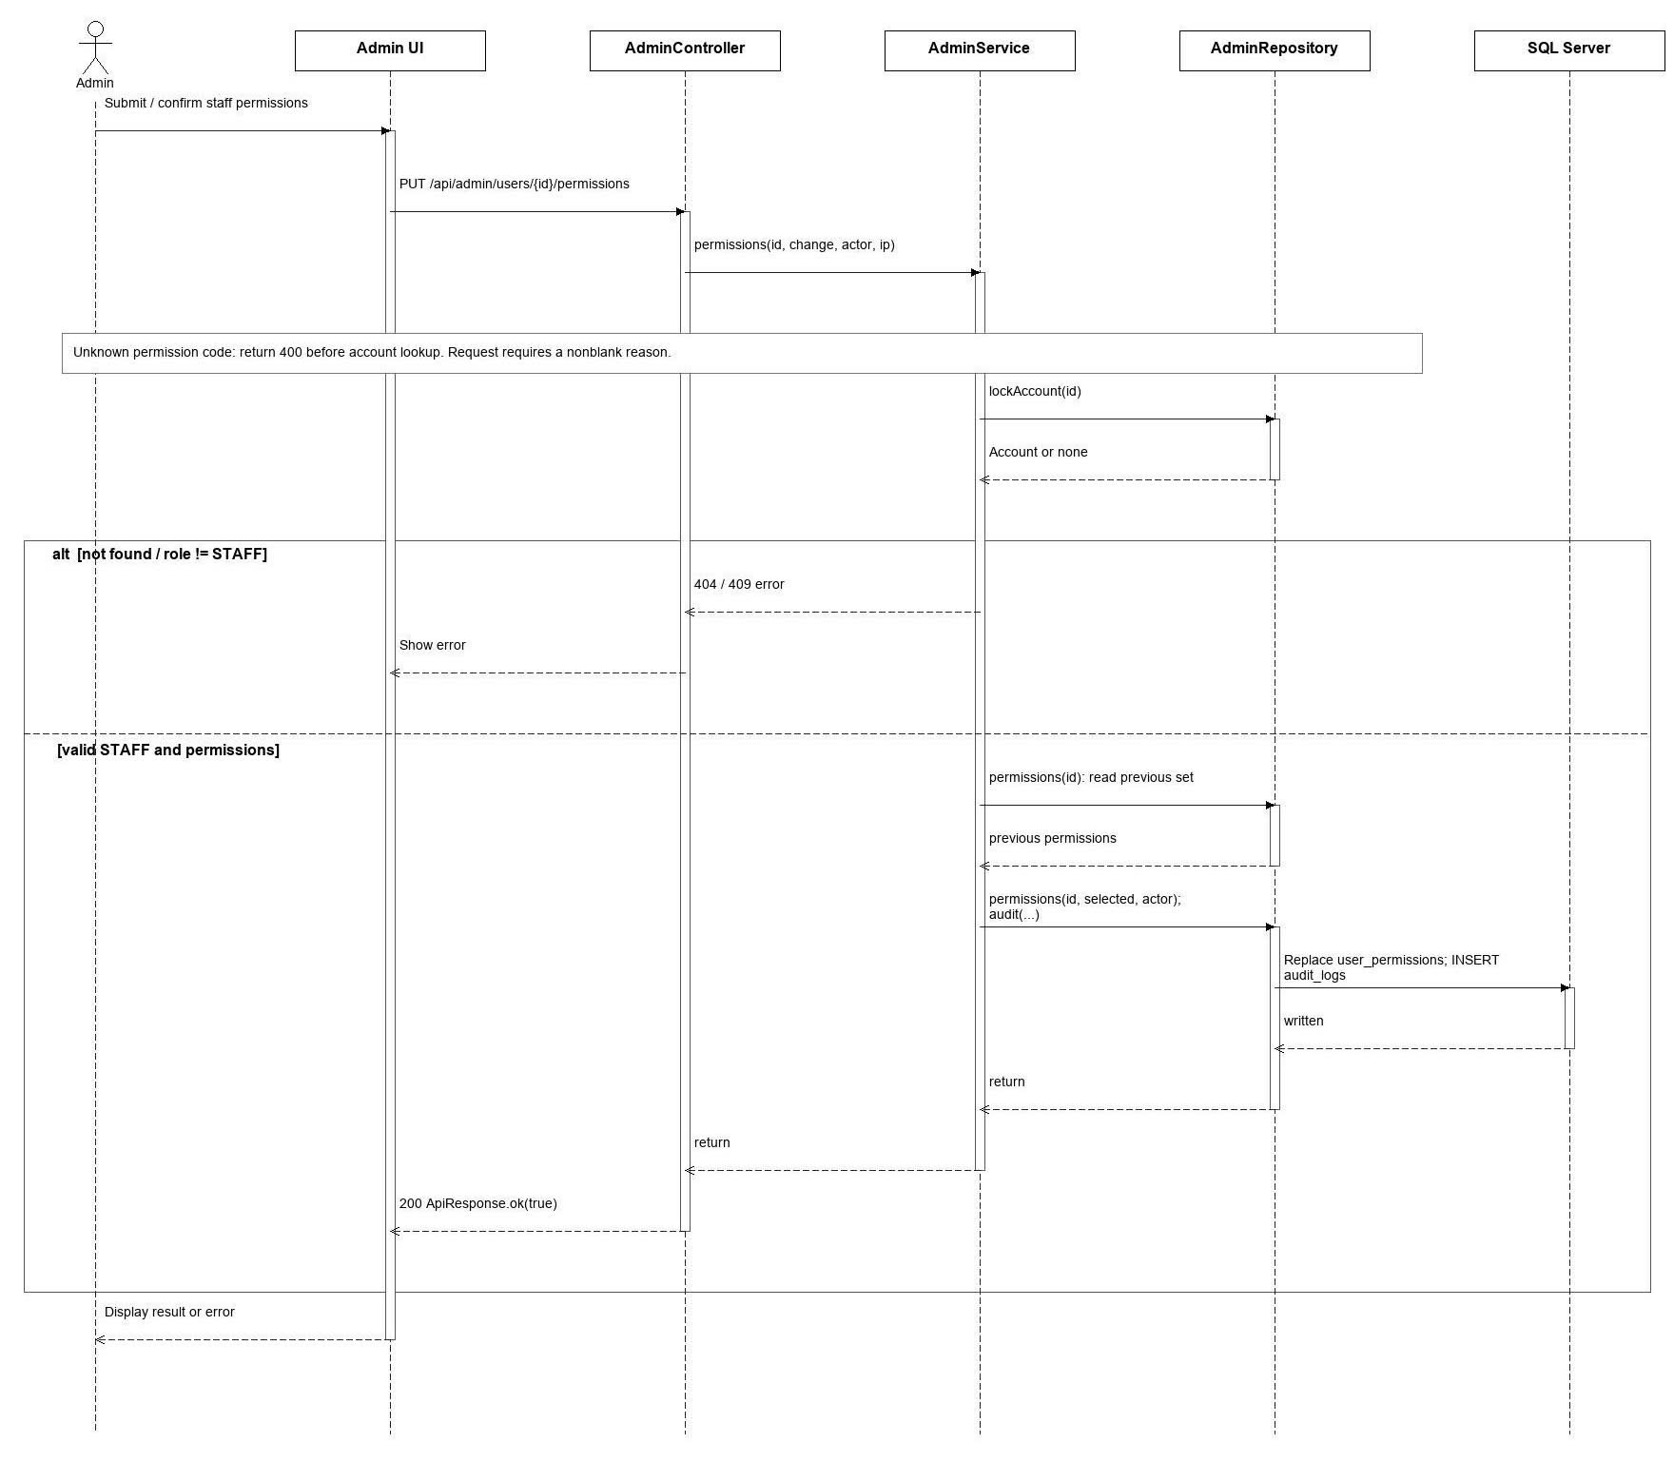

3.4 Mentorship Session Completion and Review(Nguyễn Bảo Trung)

3.4.1 Class Diagram

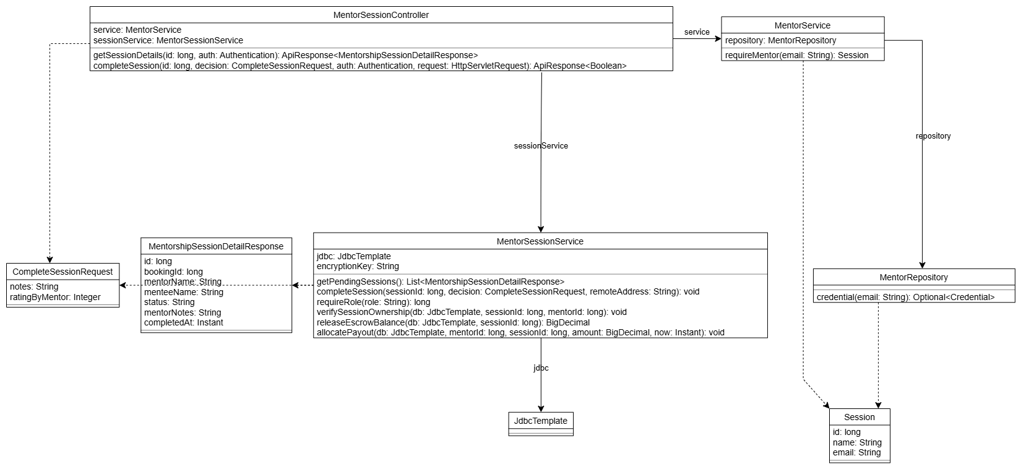

3.4.2 Sequence
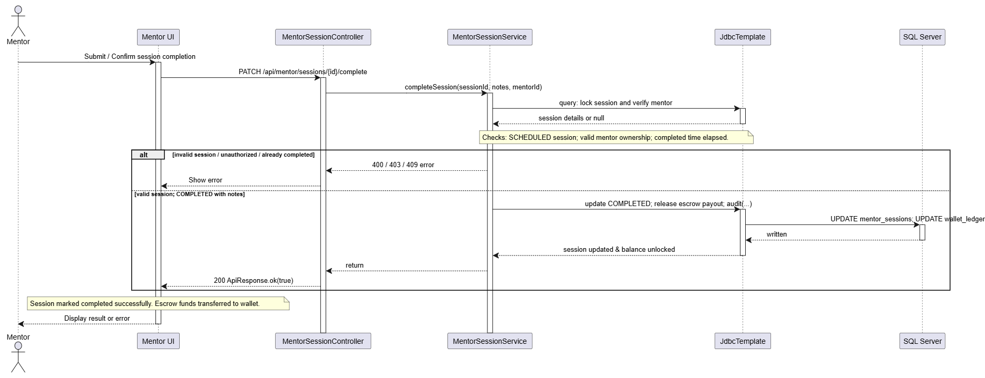

3.5 Mentor Registration and Approval (Tạ Đình Tuân_HE18400)

3.5.1.Class diagram :
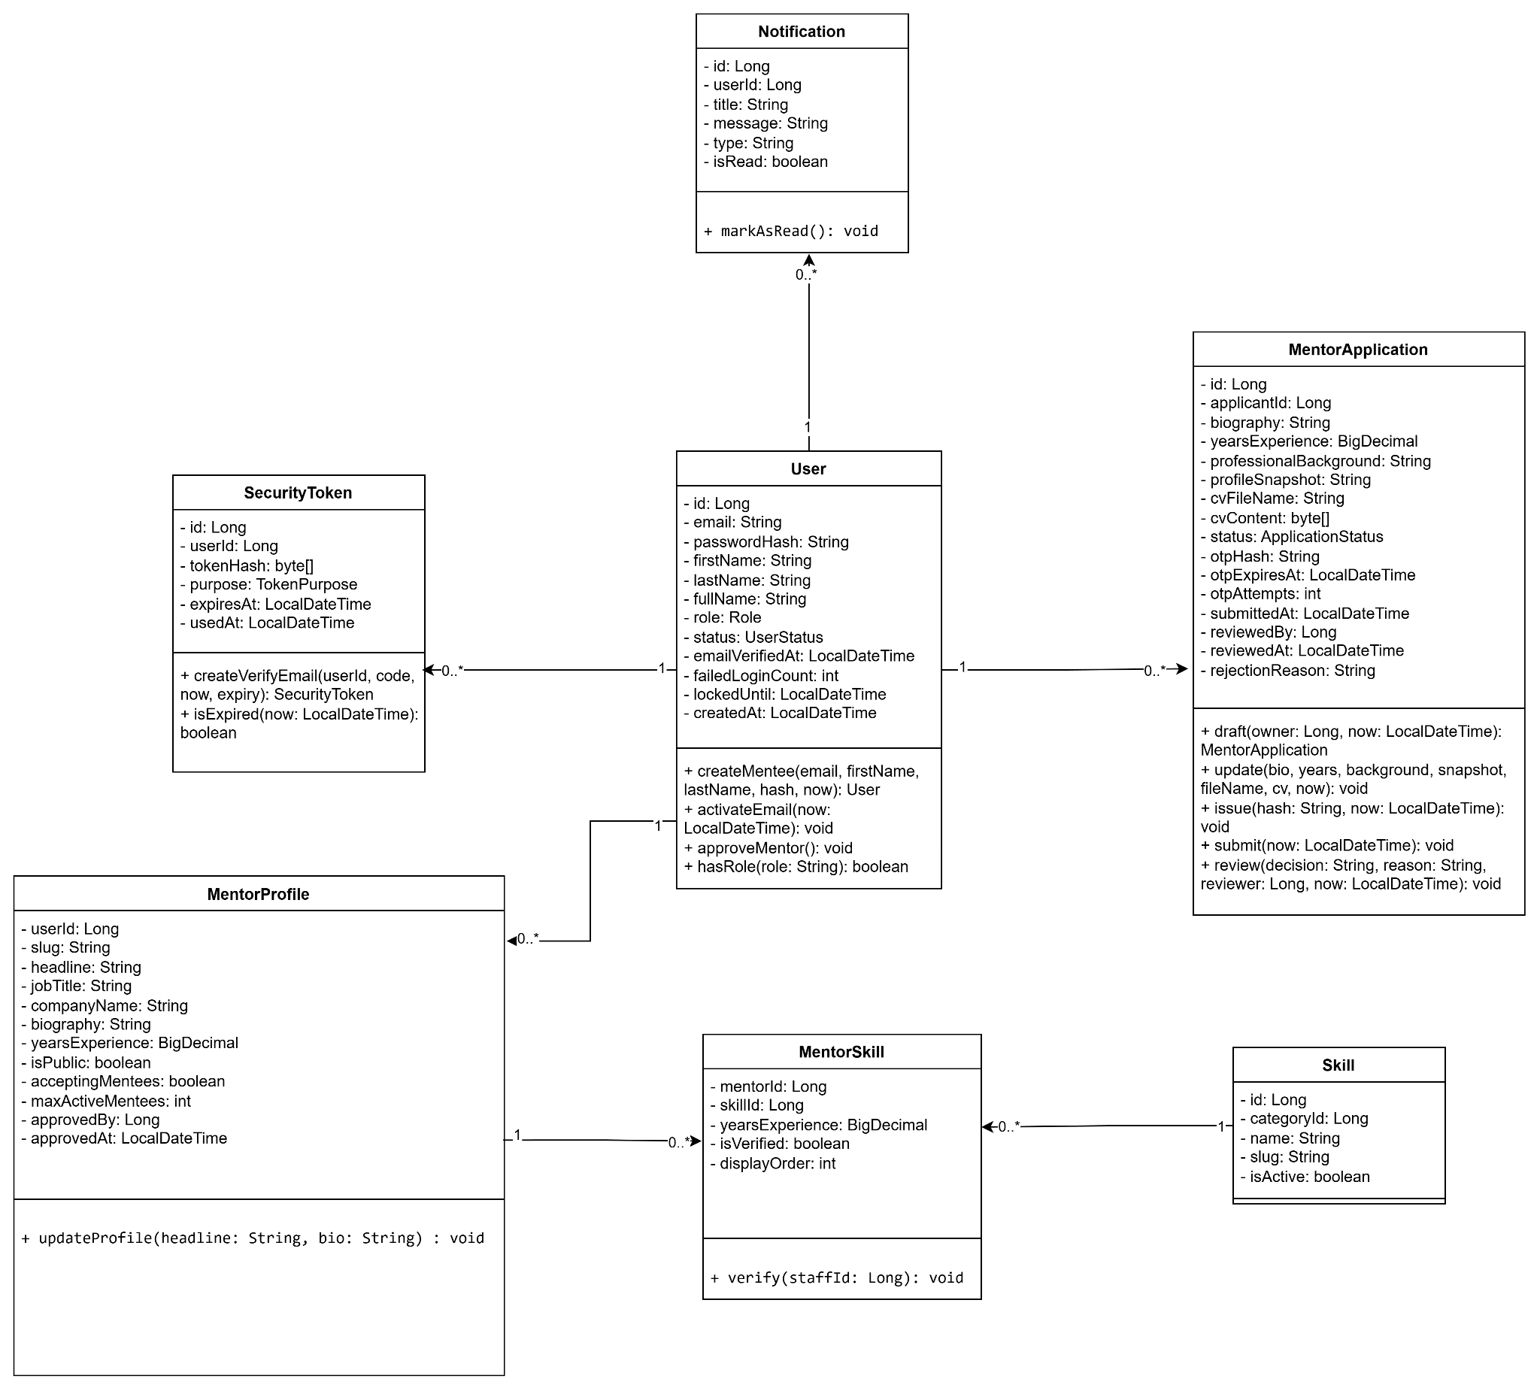

3.5.2. Mentor Registration and Account Verification
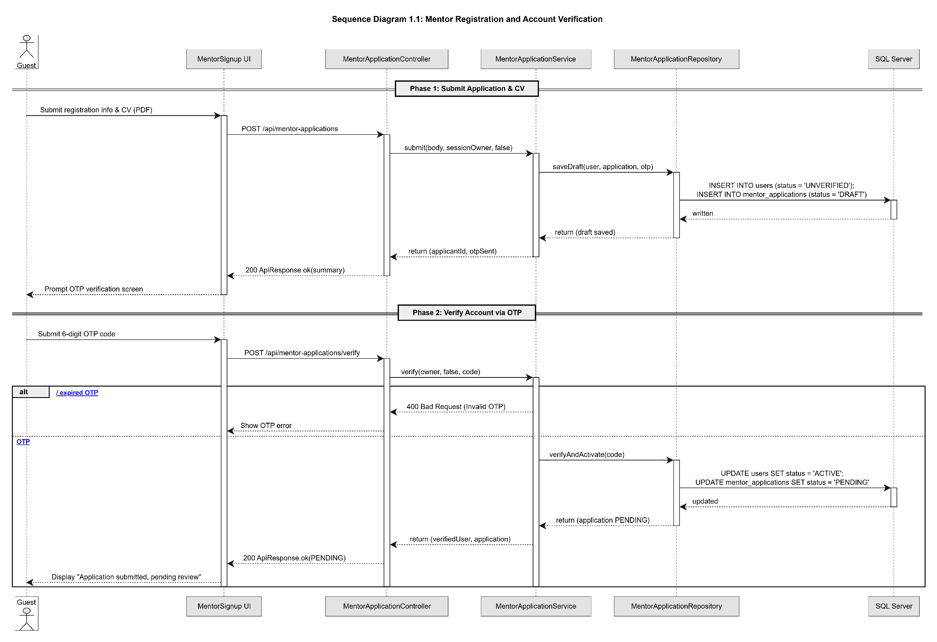

3.5.3.Sequence diagram :

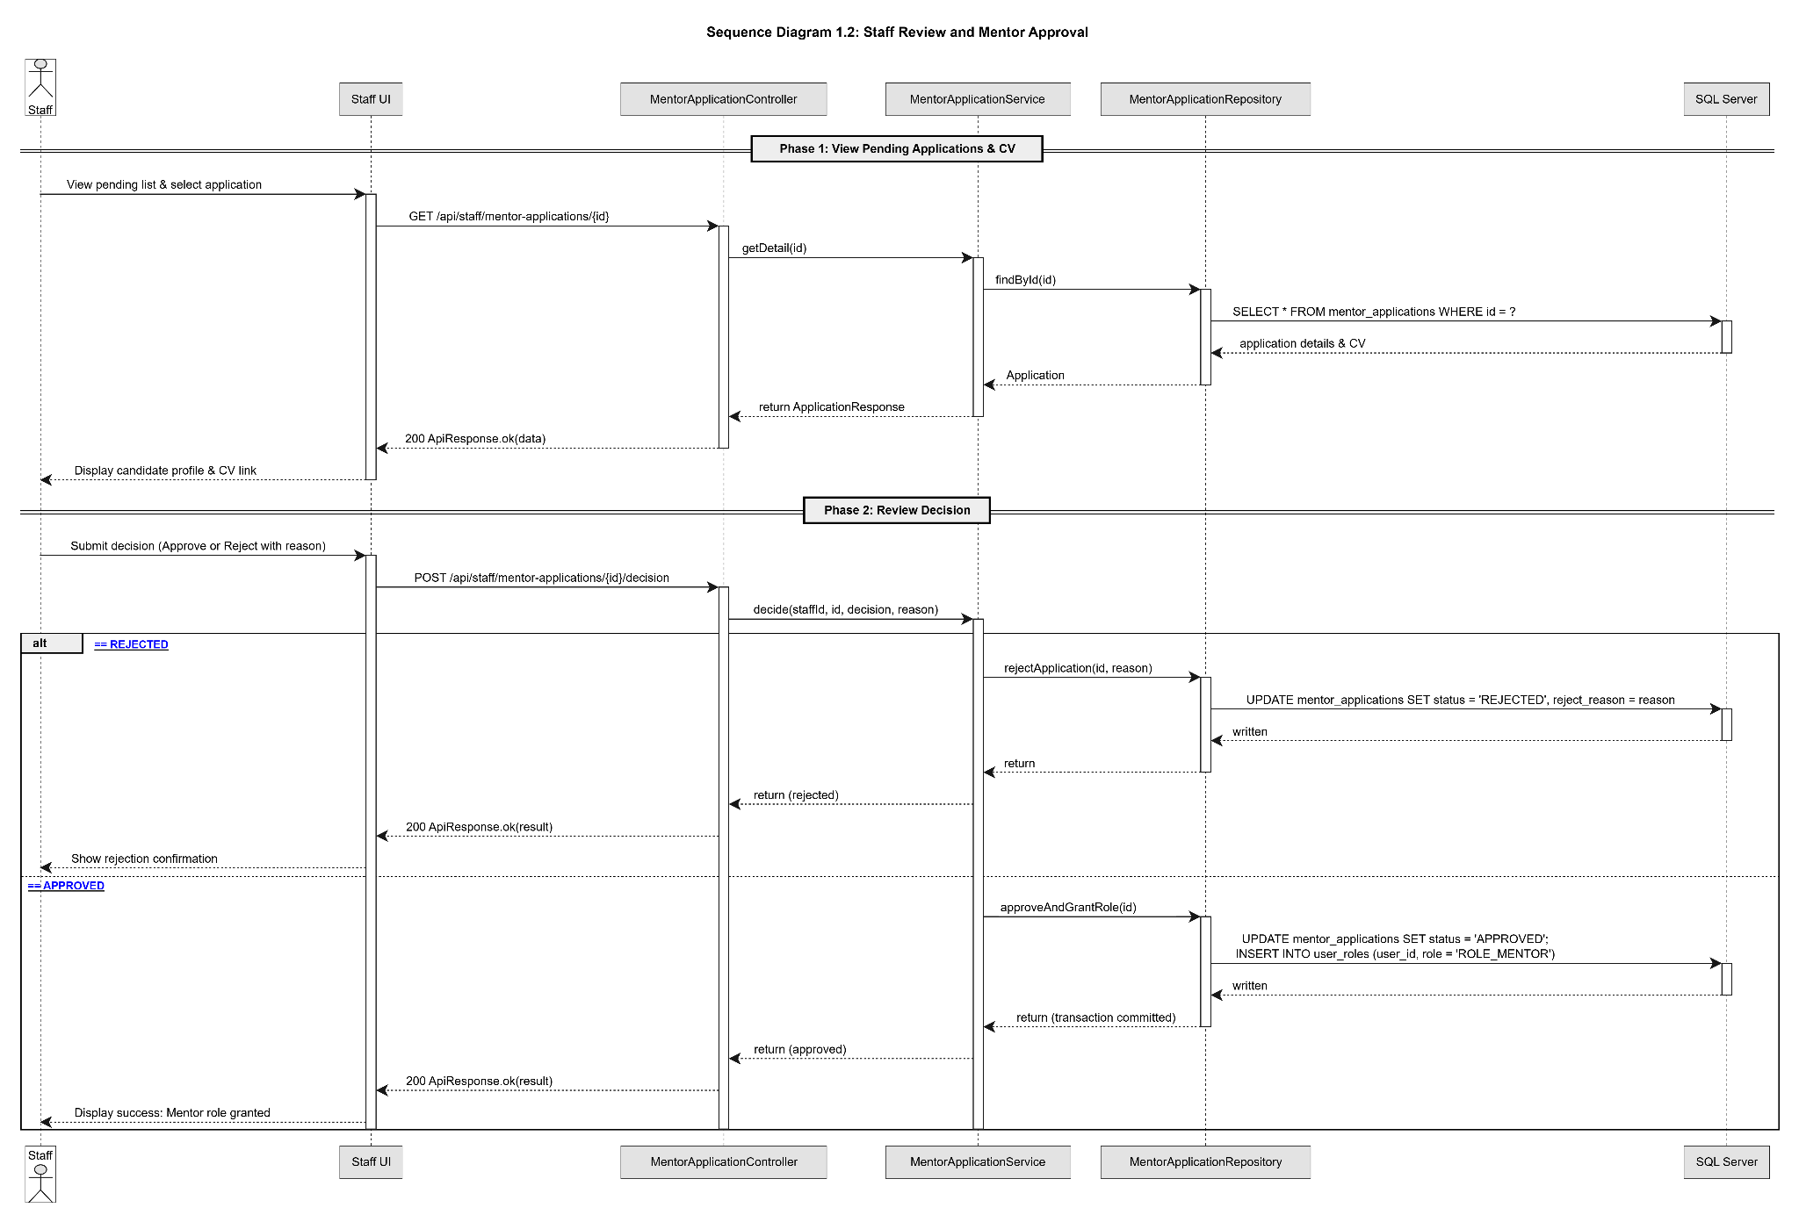

3.6 Mentor Payout Management(Bùi Đức Lương)

3.6.1.Class diagram
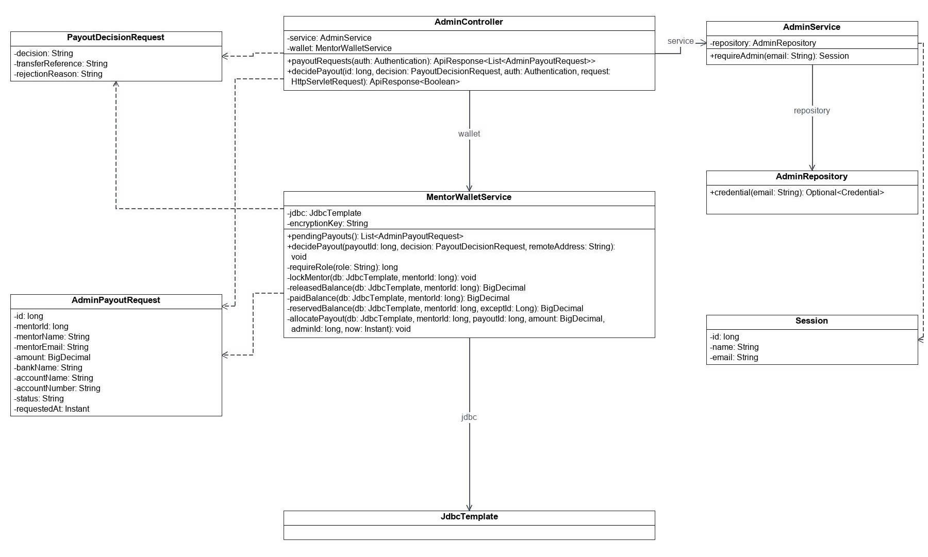

3.6.2 Sequence


